

Dear Parents,
Thank you for registering and trusting us with the care of your child for the
2017-2018 school year. We are looking forward to a fun filled and enriching year!

Children of Hope provides a nurturing environment where children and families are encouraged to grow and develop together. Growth is enhanced in all domains: spiritual, cognitive, social, emotional and physical. Children learn through a wonderful combination of play and academics and our program is developmentally and age appropriate for the individual child.

This Enrollment Packet contains the following information:
- Program Overview
- Schedule and Fees
- Registration Form
- Financial Contract
- School Calendar

Please return forms upon registration. You will receive a Parent Handbook at our Parent Orientation at the beginning of August.

Welcome!

Lynn Hockenberger
Preschool Director

2601 E. Thunderhill Place, Phoenix, AZ 85048
Phone (480) 759-1515 Fax (480) 759-1436
childrenofhope@myesperanza.org

Children of Hope Child Development Center makes no discrimination in admissions or determination of enrollment on the basis of race, sex, color, national origin or religion.
Children of Hope is committed to providing a positive and hands-on learning community where children can explore and create. Curriculum happens all day, in every routine, as we nurture the students’ spiritual, social-emotional, cognitive and physical growth through child-centered developmental lessons. We form a true partnership with the family to build a strong foundation that will foster a life-long love of learning.
Based upon developmentally appropriate practices as described by the National Association for the Education of Young Children (NAEYC), the Evangelical Lutheran Education Association (ELEA), The Creative Curriculum and the Arizona Department of Education’s Early Learning Standards, Children of Hope has created a learning community that puts into practice what is known from research of how children learn in early childhood education.

Children of Hope is an active member of the Evangelical Lutheran Education Association and the school’s director holds membership in the National Association for the Education of Young Children and the Faith Representative seat on the East Maricopa Regional Council of First Things First.

More information on these important organizations can be found below:
http://www.eleanational.org/http://www.azed.gov/

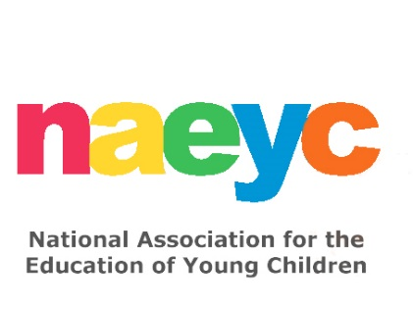http://www.naeyc.org/

http://www.firstthingsfirst.org

http://www.firstthingsfirst.org/httphttp://www.firstthingsfirst.org/http://www.firstthingsfirst.org/http://wg/hhhhhhhhttp://www.firstthingsfirst.org/
Our Purpose
- To recognize the uniqueness of each child and encourage self-esteem and individuality.
- To provide a strong, developmentally appropriate academic foundation for each child, helping to ensure future success through kindergarten transition and beyond.
- To provide purposeful work times and opportunities for children to ask questions, pursue ideas, get messy and creative, and thrive.
- To encourage each child to be concerned for others, to cooperate in work and play, and to develop a spirit of sharing.
- To provide an environment where Christian values are not just studied, but lived, with teachers showing examples of Christ’s way of love, acceptance and forgiveness.
- To form a partnership with families that encourages growth and success for each child.

Our Program Consists of…
- Degreed/Certified Christian teachers who care about your child’s total development and continually work to broaden their knowledge of Early Childhood Education.
- Hands-on experiences which are developmentally appropriate to each child’s stage of development.
- Planned experiences for the WHOLE child.

Jesus said: “Let the little children come to me and do not hinder them, for the kingdom of heaven belongs to such as these.” Matthew 19:14

THE TWO YEAR OLD CLASS is a three-hour class that meets two days a week in which a variety of developmentally appropriate learning activities occur. Structuring the environment and planning activities for self-directed play, social interaction and learning is a fundamental part of the program. Curriculum activities include dramatic play, open-ended creative and sensory experiences (painting, sand and water play, modeling clay, collage activities, etc), construction activities with blocks and manipulative toys, gardening and outdoor activities. Different colors, animals, foods, numbers, shapes, and other topics are explored each day with books, art, and songs. The children get lots of love, attention, and nurturing everyday to make sure they feel safe, secure, and happy. Children do not have to be potty trained to join this class.

THE THREE YEAR OLD CLASSES meet for three hours each day, two or three days per week. This class works toward helping the children verbalize their feelings and needs and toward developing positive social relations. At three, there is more role-play and more cooperative play. By the end of the year, playgroups have increased in size with four or five children interacting in the housekeeping corner or on the playground with imaginative play. There are group times, which include songs, stories, finger plays, art, music, and fun body movement activities. In addition, the children get a strong introduction to early childhood academics. Name and letter recognition, number recognition, one to one correspondence, shapes, etc. are explored and the children get a chance to enhance this academic learning with art projects, activities, and class themes. Games and activities also include making and identifying patterns, shapes, numbers, counting, and sorting. Every day the children have fun and gain a sense of pride and accomplishment with a specific job they are assigned. The children’s fine motor skills are strengthened during art activities and children are encouraged to express themselves in the writing center. At first the writing just appears to be scribbles, but this is the beginning of developing the ability to write letters and numbers.

THE FOUR YEAR OLD PRE-KINDERGARTEN CLASSES meet for three hours, three or four days per week. All children in this group, by age, will be eligible for Kindergarten the following year. A typical day in this program provides developmentally appropriate experiences in all domains: cognitive, social, emotional, physical and spiritual. This theme and center-based program allows children to utilize materials in more complex and extended ways. Many of the activities promote the children’s phonemic awareness and are critical to early reading success. Early mathematical skills are also developed with graphing, sorting, counting, and basic addition and subtraction. The children practice writing letters and numbers in different activities daily. They also improve their fine motor skills with activities including cutting, painting, coloring, and gluing. Scientific topics are presented to the children in fun and interesting, hands-on ways.

All of our classes include the following:
- Opening Circle (welcome, story time, calendar, music, etc.)
- Small Group Time (art, science, math, writing, reading, etc)
- Outdoor Time (every day the children have large motor skill play in the outdoor play area)
- Bathroom/Handwashing/Snack
- Music/Movement
- Quiet Reading
- Free Choice (small group activities, interest centers open for learning, free play, creative art activities, math and science experiences)
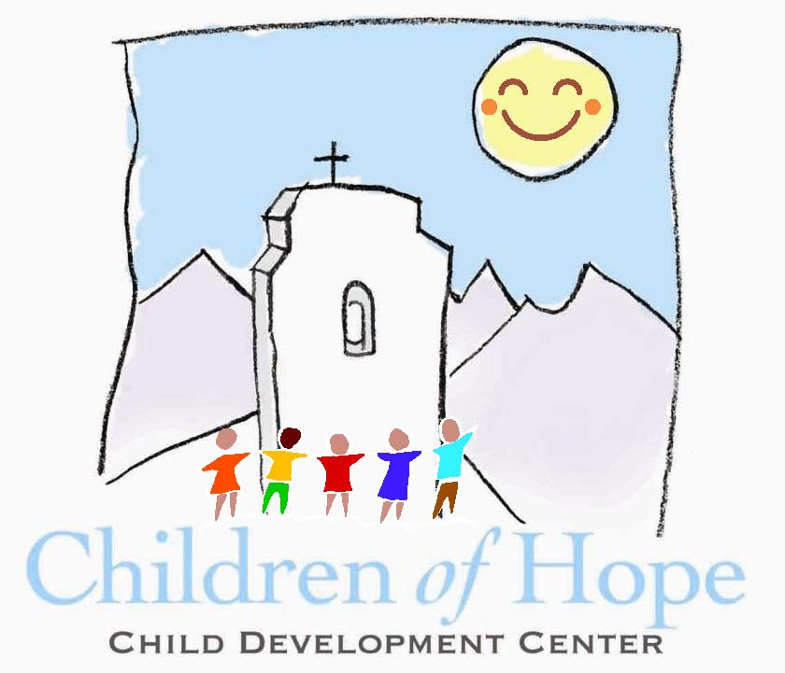
SCHEDULE AND FEES FOR FALL/SPRING 2017-2018

All tuition is based on a yearly amount and is payable in ten installments for August through May school year. Tuition payments are due on the 1st of the month.
A non-refundable registration fee of $150.00 is payable upon enrollment.
Consideration for registering two or more children is as follows:
Second child $127.50 and third child is $80.00.

Class | Days | Time | Monthly  Rate | Size | Age of Child
Toddler Class | T/Th | 8:30 – 11:30 | $260.00 | 1:4 | 2 yrs by 8-31-17
3’s Class | T/Th | 8:30 – 11:30 | $250.00 | 1:7 | 3 yrs by 8-31-17
3’s Class | M/W/F | 8:30 – 11:30 | $300.00 | 1:7 | 3 yrs by 8-31-17
Pre-Kindergarten (3 day) or | M/W/F | 8:30 - 11:30 | $310.00 | 1:7 | 4 yrs by 8-31-17
Pre-Kindergarten (4 day) | M/T/W/Th | 8:30 - 11:30 | $370.00 | 1:7 | 4 yrs by 8-31-17
All fees and tuition payments are non-refundable. A 15% tuition discount will be applied to a second child enrolled in the same family.

Enrichment Classes and Lunch Bunch (3’s Class and up) are offered for an additional fee between the hours of 11:30am – 2:00pm daily.

2601 E. Thunderhill Place Phoenix, AZ 85048
Phone 480-759-1515 Fax 480-759-1436 childrenofhope@myesperanza.org
CHILDREN OF HOPE CHILD DEVELOPMENT CENTER MAKES NO DISCRIMINATION IN ADMISSIONS OR DETERMINATION OF ENROLLMENT ON THE BASIS OF RACE, SEX, COLOR, NATIONAL ORIGIN OR RELIGION
Children of Hope Preschool Calendar
2017-2018

The following is a list of notable days and holidays for the Preschool Academic Year (based on Kyrene School District). Please understand that we will follow this as closely as possible and notify you as soon as possible with changes that Kyrene District or we might make.

September 5 Show & Tell Night: 6:15-7:00pm
October 6 – 16 No School: Fall Break
October 30/31 Halloween Party
November 10 No School: Veteran’s Day
November 21/22 Thanksgiving Feast
November 23 and 24 No School: Thanksgiving Holiday
December 2 Breakfast with Santa
December 12 Evening Christmas Program
December 20/21 Gingerbread House Day
December 22 - January 5 Christmas Break
January 8 and 9 Classes Resume
January 15 No School: MLK Jr. Holiday
February 19 No School: President’s Day
March 12 - 19 No School: Spring Break
March 28/29 Easter Egg Hunt
March 30 No School: Good Friday
May 9 - 11 Mother’s Day Tea
May 17/18 Last Day of Preschool
REGISTRATION
CHILDREN OF HOPE PRESCHOOL
2601 E. Thunderhill Place Phoenix, AZ 85048 (480) 759-1515

CHILD________________________________________________________________________M or F
Last Name First Middle
ADDRESS __________________________________________________________________________
Street City Zip
DATE OF BIRTH ______________________AGE ______FREE SCHOOL T-SHIRT SIZE_____XS_______S
Month Day Year

PARENT/GUARDIAN INFORMATION
Mother’s Legal Name ___ Lives with student Father’s Legal Name ____ Lives with student
______________________________________ _________________________________________
Marital Status: ___ Married ___ Separated Martial Status: ___ Married ___ Separated
___ Divorced ___ Widowed ___ Single ___ Divorced ___ Widowed ___ Single
Mother’s Address: Father’s Address:
______________________________________ _________________________________________
______________________________________ _________________________________________
Home Phone: Cell Phone: Home Phone: Cell Phone:
_____________ ______________ _____________ ________________
Occupation: Work Phone: Occupation: Work Phone:
_____________ ______________ _____________ ________________

Email Address: Email Address:
______________________________________ _________________________________________

OTHERS IN HOUSEHOLD
NAME RELATIONSHIP TO CHILD AGE

STUDENT BACKGROUND

What is your religious affiliation? ________________________________________________________
Has your child been in preschool before? ___ Yes ___ No How Long? ____________

DOES YOUR CHILD HAVE ANY ALLERGIES OR HEALTH PROBLEMS THAT WOULD RESTRICT HIS/HER PARTICIPATION IN ANY PRESCHOOL ACTIVITES? ____________________________________________________________________________________
Is there anything else we should know about your child? ______________________________________
____________________________________________________________________________________
In signing this application, I understand that:
- The registration fee is NON-REFUNDABLE
- Tuition is due the first of each month (a total of 10 monthly payments –August - May)
- The teachers will use separation or re-direction in matters of discipline
- Parents are welcome to visit the classroom at any time. Please coordinate with your teacher.

Parent Signature: ____________________________________ Date: ________________________
Class Assignment: ___________________________________ Fees Paid: ____________________

******************************************************************************************************************************
Children of Hope Child Development Center makes no discrimination in admissions or determination of enrollment on the
basis of race, sex, color, national origin or religion.
Children of Hope Child Development Center
2017-2018 Parent Participation Agreement

Please read and initial the following statements. If you have questions, please do not initial any item until you have had your question answered by the CoH staff and understand it completely.

_____ I understand that all programs are based on meeting minimum enrollment requirements.

_____ I understand that I must maintain updated medical information annually and be current on all immunizations required by the Department of Health.

_____ I understand that registration fees and paid tuitions are non-refundable and non-transferable under any circumstance.

______I understand that monthly tuition is based on a yearly fee, broken into 10 installments. No discounts are given for illnesses, vacations or absences.

_____ I understand that tuition is due on the 1st of each month, August – May. Tuition is late if received after the 10th. I understand that I can be assessed a $15 late fee for payments received or postmarked after the due date and a $15 late fee for NSF checks.

_____ I understand that I may mail or hand deliver my check made out to Esperanza Lutheran Church to the school office or tuition box in order to meet the deadline.

_____ I understand the importance of reading all information provided to me by CoH staff in a timely fashion including my Family Handbook, emails, notes, newsletters, flyers and Parent Orientation Packet.

_____ I understand that my child will be released ONLY to those individuals whose names are listed on the DHS health form. Release to anyone other than those listed on the DHS health form will require arrangements with the Director.

_____ I understand that my child will be released from the program if he/she cannot benefit from the program or presents a danger to self or others as determined by teacher(s) and Director.

_____I understand that monies raised from fundraisers/events throughout the year help supplement and support programs at the school.

_____ I understand that a 30-day paid notice is required if I decide to withdraw my child from the program. Withdrawals must be done in person and submitted in writing with the Director. Registration fees and paid tuition cannot be pro-rated or refunded under any circumstance.

Parent Signature______________________________________________________Date_____________
Children of Hope Child Development Center
Photo Release Form

I, ____________________________hereby authorize ____________________________
(Parent or Guardian) (Name of Student)

to participate in the making of projects consisting of photographs, video, film production, internet / website titled “Children of Hope Preschool” on or about the 2017-2018 school year. I specifically understand that Children of Hope Child Development Center shall hereby retain any and all rights in the photograph(s), or video/film production, internet/
website, including but not limited to, the right to reproduce, copy, edit, exhibit, publish, or distribute such photograph(s), video, film and/or internet.

Parent or Guardian Signature: _________________________________________

Date: ___________________________

